Bump and Pothole Detection Report

### A Major Project

*Submitted in the partial fulfillment for the award of the degree of*

# BACHELOR OF ENGINEERING IN

**Computer Science and Engineering with Specialization in Artificial Intelligence and Machine Learning**

### Submitted by:

### Akshat Mishra

# DEPARTMENT OF COMPUTER SCIENCE AND ENGINEERING

# DECLARATION

We, students of **‘Bachelor of Engineering in CSE-AIML’**, 7th Semester **session: Aug-Nov 2024**, Department of Computer Science and Engineering from Shri Ramswaroop Memorial college of engineering and management hereby declare that the work presented in this Project Work entitled **‘Bump and Pothole Detection’ is** the outcome of our own bona fide work and is correct to the best of our knowledge and this work has been undertaken taking care of Engineering Ethics. It contains no material previously published or written by another person nor material that has been accepted for the award of any other degree or diploma of the university or other institute of higher learning, except where due acknowledgment has been made in the text.

# Table of Contents

# Contents

|  |  |  |
| --- | --- | --- |
|  | Title Page  Declaration of the Student Abstract Acknowledgement | i |
| ii |
| iii |
|  | **INTRODUCTION\*** | **1-15** |
|  | * 1. Problem Definition and Overview   2. Software Specification   3. Hardware Specification | 8  9  12 |
| **LITERATURE SURVEY**   * 1. Existing Studies   **PROBLEM FORMULATION** | | **13-16** |
| **17-20**  **21**  **22-35**  **46-51**  **52-63**  **64-68** |
| **OBJECTIVES**  **METHODOLOGY**  **CODES**  **CONCLUSIONS AND DISCUSSION**  **REFERENCES** | |

**ABSTRACT**

With the growing reliance on autonomous vehicles and the increasing emphasis on road safety, the detection and analysis of road surface anomalies such as bumps and potholes have become crucial aspects of transportation infrastructure management. This paper provides a comprehensive review of the current state-of-the-art techniques and technologies employed in the field of bump and pothole detection.

The review encompasses a wide range of methodologies, including sensor-based approaches, computer vision techniques, and machine learning algorithms. Sensor technologies such as accelerometers, gyroscopes, and LIDAR play a pivotal role in real-time data acquisition, while computer vision methods leverage image processing and object recognition to identify road irregularities. Machine learning algorithms, particularly deep learning models, are increasingly being employed for their ability to discern complex patterns in sensor and image data.

The paper also addresses the challenges associated with bump and pothole detection, such as environmental variability, sensor noise, and the need for robust algorithms capable of handling diverse road conditions. Furthermore, it discusses the integration of these detection systems with existing transportation infrastructure and their potential impact on road maintenance and safety.

In addition to surveying the current landscape, the paper explores future directions in the field. This includes the potential incorporation of emerging technologies such as 5G connectivity, edge computing, and swarm intelligence to enhance the accuracy and efficiency of bump and pothole detection systems. Moreover, the paper discusses the implications of these advancements for the development of intelligent transportation systems and their role in creating safer and more sustainable road networks.

Potholes along with speed bumps have been a cause of worry for motorists for a long time. Recent reports show that in India there are more than 10,000 accidents due to potholes and bumps. In this paper, we attempt to identify the road surface by classifying it into potholes, speed bumps, and normal roads based on image data. The method of classifying the road surface from the images using convolution neural networks, ResNet-50 is discussed. Initially, the images are manually classified into three classes and these are used to train the neural network, we were able to achieve a true positive rate of 88.9%. In the second phase, we pass the image to an object detection neural network to detect the precise location of the speed bump.

In conclusion, this review provides valuable insights into the ongoing efforts and innovations in bump and pothole detection, offering a foundation for researchers, practitioners, and policymakers to further advance the field. The integration of cutting-edge technologies and methodologies holds the promise of significantly improving road safety, reducing maintenance costs, and ultimately contributing to the realization of intelligent and resilient transportation systems.

# ACKNOWLEDGEMENT

It gives us immense pleasure to express our deepest sense of gratitude and sincere thanks to our respected guide Monika Singh (Assistant Professor), CSE- Artificial Intelligence, Chandigarh University, Mohali for his valuable guidance, encouragement, and help in completing this work. His useful suggestions for this whole work and cooperative behavior are sincerely acknowledged. We are also grateful to Dr. Shikha Gupta (Program Leader, CSE-AIML) for her constant support and guidance.

We also wish to express our indebtedness to our family members whose blessings and support always helped us to face the challenges ahead. We also wish to express thanks to all the people who helped us in the completion of this project.

By: Akshat Mishra (BE21CS013)

1. **INTRODUCTION**

### Bump Detection:

### Bump detection is a critical aspect of transportation safety and infrastructure management, particularly in the context of road maintenance and vehicle safety. Bumps on roads can pose significant challenges for drivers, passengers, and the structural integrity of vehicles. Detecting and addressing bumps in a timely manner is essential for ensuring smooth and safe transportation experiences. Various technologies and methodologies are employed in the field of bump detection to enhance road safety and infrastructure maintenance. Here, we explore the key aspects of bump detection, including the methods used, technologies involved, and the broader implications for transportation systems.

Recognition algorithms can be divided into two main approaches:

1. **Sensor-Based Approaches:**
   * **Accelerometers and Gyroscopes:** These sensors are commonly integrated into vehicles and measure changes in acceleration and orientation. Sudden jolts or changes in vehicle dynamics can indicate the presence of a bump.
   * **Inertial Measurement Units (IMUs):** IMUs combine data from accelerometers and gyroscopes to provide comprehensive information about a vehicle's motion. Sudden changes in acceleration can be indicative of road irregularities.
2. **Computer Vision:**
   * **Image Processing:** Cameras mounted on vehicles capture images of the road surface. Image processing algorithms analyze these images to detect changes in texture, color, or patterns, indicating the presence of bumps.
   * **Object Recognition:** Advanced computer vision techniques, including deep learning models, can be trained to recognize specific features associated with bumps. Convolutional Neural Networks (CNNs) are particularly effective in learning hierarchical features from road images.
3. **Machine Learning and Data Fusion:**
   * **Feature Extraction:** Machine learning algorithms can extract relevant features from sensor data or image inputs that are indicative of bumps. These features may include sudden changes in acceleration, visual cues, or patterns in the road surface.
   * **Supervised Learning:** Training machine learning models on labeled datasets enables the system to learn the characteristics of bumps and differentiate them from normal road conditions.
   * **Data Fusion:** Combining information from multiple sensors, such as accelerometers, cameras, and LIDAR, can improve the accuracy and reliability of bump detection systems.

### 

### Picture 1- bumps

### Pothole Detection:

Pothole detection is a crucial aspect of road maintenance and vehicle safety, aiming to identify and assess the presence of potholes on road surfaces. Several approaches, combining various technologies and methodologies, are employed for effective pothole detection. Here's an overview of common methods used in pothole detection:

1. **Sensor-Based Approaches:**
   * **Accelerometers and Gyroscopes:** Similar to bump detection, these sensors are integrated into vehicles and measure changes in acceleration and orientation. Sudden jolts or variations in vehicle dynamics can indicate the presence of potholes.
   * **Inertial Measurement Units (IMUs):** IMUs, combining data from accelerometers and gyroscopes, provide comprehensive information about a vehicle's motion, helping to identify sudden changes associated with potholes.
2. **Computer Vision:**
   * **Image Processing:** Cameras mounted on vehicles capture images of the road, and image processing algorithms analyze these images to detect variations in colour, texture, or

shape that may indicate the presence of potholes.

* + **Object Recognition:** Deep learning models, particularly Convolutional Neural Networks (CNNs), can be trained to recognize specific features associated with potholes in images, improving accuracy and reliability.

1. **Machine Learning and Data Fusion:**
   * **Feature Extraction:** Machine learning algorithms can extract relevant features from sensor data or image inputs indicative of potholes. These features may include depth, size, and shape characteristics.
   * **Unsupervised Learning:** In addition to supervised learning, unsupervised learning methods can be employed for anomaly detection, allowing the system to identify unexpected patterns indicative of potholes.
   * **Road Inspection Systems:** Dedicated vehicles equipped with advanced sensors routinely inspect roads, identifying and cataloging potholes for maintenance purposes.

Top of Form

* 1. **Project Definition and Overview**

### 

Bumps and potholes present challenges for both road users and the infrastructure itself. Bumps can affect vehicle stability, passenger comfort, and contribute to wear and tear on vehicles. Potholes, on the other hand, pose risks of damage to vehicles and can lead to accidents if not addressed promptly. Bump and pothole detection systems are instrumental in identifying these road anomalies, enabling timely interventions to mitigate their impact.

Bump and pothole detection systems leverage a variety of sensors to collect data about road conditions. These sensors include accelerometers and gyroscopes to measure changes in motion, LIDAR for creating detailed 3D maps of the road surface, cameras for visual data, and GPS for location information. The integration of these sensors provides a comprehensive dataset for analysis.

Computer vision plays a crucial role in the detection process. Cameras capture visual information, and sophisticated algorithms process these images to identify patterns associated with bumps and potholes. This involves image processing techniques and object recognition, with machine learning models enhancing the system's ability to recognize complex visual cues.

Machine learning algorithms are employed for pattern recognition and anomaly detection. These algorithms learn from labeled datasets, distinguishing normal road conditions from irregularities. Supervised learning enables the system to generalize its understanding, while unsupervised learning methods can identify anomalies without predefined patterns.

One of the key features of bump and pothole detection systems is their capability for real-time monitoring. The system processes incoming data swiftly, making instantaneous decisions such as providing alerts to drivers, adjusting vehicle parameters, or notifying authorities for necessary road maintenance.

By detecting bumps and potholes early on, these systems contribute to improving road safety and reducing accidents. Additionally, the data collected aids in prioritizing maintenance efforts, allowing authorities to address road irregularities efficiently and prevent further deterioration of the infrastructure.

The future of bump and pothole detection involves advancements in technology, such as the integration of 5G connectivity for faster data transfer, edge computing for quicker processing, and the exploration of swarm intelligence to enhance collaborative sensing capabilities. These developments aim to make detection systems more adaptive, responsive, and capable of handling diverse road conditions.

bump and pothole detection systems represent a crucial component of intelligent transportation systems, contributing to safer roads, improved infrastructure maintenance, and enhanced overall transportation experiences.

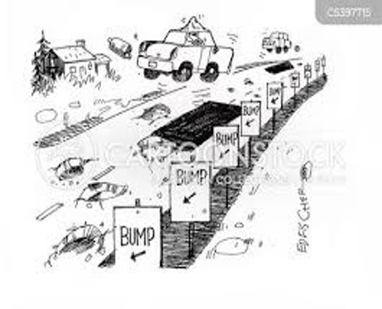

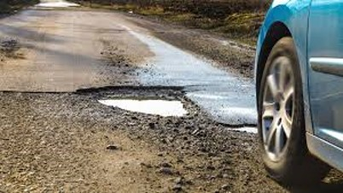

Picture 2 and Picture 3 - Road and Bumps

**FUNDAMENTAL STEPS IN IMAGE PROCESSING**

The fundamental steps in image processing are:

Data Collection:

* Sensor Integration: Collect data from accelerometers, gyroscopes, LIDAR, cameras, and GPS to capture a comprehensive view of the road conditions.
* Labeling: Annotate the data to indicate instances of bumps and potholes for supervised learning.

2. Data Preprocessing:

* Feature Extraction: Identify relevant features from the raw sensor data, such as acceleration patterns, depth information from LIDAR, and visual cues from images.
* Normalization: Standardize the features to ensure consistent scaling for effective model training.

3. Model Selection:

* Choose ML Algorithms: Select appropriate ML algorithms for the task. Common choices include decision trees, support vector machines, and, more prominently, deep learning models like Convolutional Neural Networks (CNNs) for image data and recurrent neural networks for sequential data.

4. Model Training:

* Training Dataset: Split the labeled dataset into training and testing sets.
* Supervised Learning: Train the model using the labeled data to recognize patterns associated with bumps and potholes.
* Hyperparameter Tuning: Optimize model parameters for better performance.

5. Real-Time Data Analysis:

* Continuous Monitoring: Implement the trained model for real-time analysis of incoming sensor data.
* Prediction: Use the model to predict the likelihood of bumps and potholes based on the features extracted from the live sensor data.

The fundamental steps in image processing, from the acquisition of images to advanced processing techniques.

1.Image Acquisition:

Image processing begins with the acquisition of images. The process of capturing images can involve various devices, such as cameras, satellites, or medical imaging equipment. The quality of the acquired images significantly impacts the subsequent processing steps. Different imaging modalities, such as visible light, infrared, and ultrasound, provide diverse types of images.

2. Image Representation:

Images can be represented in different ways, depending on the application and requirements. The most common representations are grayscale and color images. Grayscale images have intensity values representing the brightness at each pixel, while color images have multiple channels (e.g., red, green, and blue). Other representations include binary images (black and white) and multispectral/hyperspectral images with multiple bands.

3. Image Enhancement:

Image enhancement techniques are applied to improve the visual quality or interpretability of images. These techniques include:

Contrast Enhancement: Adjusting the intensity distribution to enhance the visibility of details.

Brightness Adjustment: Changing the overall brightness level of the image.

Histogram Equalization: Enhancing the contrast by equalizing the distribution of intensity values.

4. Image Filtering:

Image filtering involves the application of convolution operations to modify the pixel values in an image. Common filters include:

Smoothing Filters: Reduce noise and blur the image.

Sharpening Filters: Emphasize edges and fine details.

Edge Detection Filters: Highlight boundaries between regions in the image.

5. Image Restoration:

Image restoration aims to improve the quality of images degraded by noise, blurring, or other distortions. Restoration techniques include:

Noise Removal: Filtering techniques to reduce or eliminate noise.

Deblurring: Methods to recover sharpness lost due to blurring.

Super-Resolution: Enhancing image resolution beyond the sensor's capability.

6. Image Segmentation:

Image segmentation divides an image into meaningful regions or objects. This step is crucial for object recognition and understanding. Techniques include:

Thresholding: Dividing the image into regions based on intensity levels.

Clustering: Grouping similar pixels based on features.

Edge-Based Segmentation: Detecting boundaries between different regions.

7. Feature Extraction:

Feature extraction involves capturing relevant information from images to represent objects or patterns effectively. Features can include edges, corners, textures, and more. Common techniques include:

Corner Detection: Identifying key points in an image.

Texture Analysis: Extracting information about spatial patterns.

Shape Descriptors: Representing the geometry of objects.

8. Image Recognition and Classification:

Image recognition involves assigning labels or categories to objects or scenes in images. Classification algorithms, often based on machine learning, use extracted features to recognize objects. Deep learning techniques, especially convolutional neural networks (CNNs), have shown remarkable success in image classification tasks.

9. Image Registration:

Image registration aligns multiple images of the same scene to a common coordinate system. It is crucial in applications such as medical imaging, remote sensing, and computer vision. Techniques include point-based, intensity-based, and feature-based registration.

10. Morphological Processing:

Morphological processing deals with the shape and structure of objects in images. Operations like dilation, erosion, opening, and closing are applied to manipulate image structures. Morphological processing is commonly used in image segmentation and feature extraction.

11. Color Image Processing:

Color image processing involves manipulating and analyzing images with multiple color channels. Techniques include color space transformations, color correction, and color-based segmentation. Understanding color models such as RGB, HSV, and CMYK is essential in color image processing.

12. Image Compression:

Image compression reduces the storage space and transmission bandwidth required for images. Compression can be lossless or lossy. Common compression techniques include JPEG, PNG, and GIF for lossy compression, and PNG and TIFF for lossless compression

13. Image Understanding and Interpretation:

Image understanding involves extracting high-level information from images, going beyond pixel-level analysis. This may include recognizing complex scenes, objects, and relationships. Advanced techniques involve semantic segmentation, object detection, and scene understanding.

14. 3D Image Processing:

In medical imaging and computer vision, three-dimensional (3D) image processing is crucial. Techniques include 3D reconstruction, volume rendering, and 3D feature extraction. These methods are applied in fields such as medical diagnostics and virtual reality.

15. Deep Learning in Image Processing:

Recent advancements in image processing leverage deep learning, especially convolutional neural networks (CNNs). Deep learning models have shown state-of-the-art performance in tasks such as image classification, object detection, and image generation.

Conclusion:

Image processing is a vast and dynamic field with a wide range of applications. The fundamental steps discussed here provide a structured approach to understanding and processing images. From image acquisition to advanced processing using deep learning, each step contributes to the overall goal of extracting meaningful information from visual data. As technology continues to advance, image processing will play an increasingly vital role in shaping various industries and scientific research.

* The algorithms associated with the fundamental steps in image processing that I mentioned earlier:

1. Image Enhancement:

Histogram Equalization:

Algorithm:

Compute the histogram of the image.

Compute the cumulative distribution function (CDF) of the histogram.

Map the pixel values to new values using the CDF.

Purpose: Enhances the contrast in an image by redistributing intensity values.

2. Image Filtering:

Gaussian Filter:

Algorithm:

Define the size and standard deviation of the filter.

Convolve the image with the Gaussian kernel.

Purpose: Smoothes the image to reduce noise and blur.

Sobel Operator (Edge Detection):

Algorithm:

Convolve the image with Sobel kernels for horizontal and vertical edges.

Compute the gradient magnitude.

Purpose: Highlights edges in the image.

3. Image Restoration:

Wiener Filter:

Algorithm:

Compute the power spectral density (PSD) of the noisy image and the ideal image.

Apply the Wiener filter formula.

Purpose: Restores images corrupted by additive noise.

4. Image Segmentation:

K-Means Clustering:

Algorithm:

Choose the number of clusters (K).

Initialize cluster centroids.

Assign each pixel to the nearest centroid.

Update centroids.

Repeat steps 3-4 until convergence.

Purpose: Segments the image into K clusters based on pixel similarity.

5. Feature Extraction:

Harris Corner Detector:

Algorithm:

Compute the gradient of the image.

Compute the second-moment matrix.

Compute the Harris response function.

Threshold and detect corners.

Purpose: Identifies key points in the image.

6. Image Recognition and Classification:

Convolutional Neural Networks (CNNs):

Algorithm:

Input layer: Receive the raw pixel values of the image.

Convolutional layers: Learn features using convolutional filters.

Pooling layers: Downsample the spatial dimensions.

Fully connected layers: Make predictions based on learned features.

Purpose: Classifies images based on learned hierarchical features.

7. Image Registration:

Iterative Closest Point (ICP):

Algorithm:

Match corresponding points between images.

Estimate transformation parameters.

Apply transformation and iterate.

Purpose: Aligns two or more images by minimizing the distance between corresponding points.

8. Morphological Processing:

Dilation and Erosion:

Algorithm:

Define a structuring element (kernel).

Slide the kernel over the image.

For dilation, set the output pixel to the maximum value under the kernel.

For erosion, set the output pixel to the minimum value under the kernel.

Purpose: Alters the shape of objects in the image.

9. Color Image Processing:

Color Space Transformation (e.g., RGB to HSV):

Algorithm:

Convert RGB values to the target color space.

Purpose: Enables better representation and manipulation of color information.

10. Image Compression:

JPEG Compression:

Algorithm:

Convert image to YCbCr color space.

Apply discrete cosine transform (DCT).

Quantize coefficients.

Entropy encode the quantized coefficients.

Purpose: Lossy compression by discarding high-frequency information.

11. Image Understanding and Interpretation:

Convolutional Neural Networks (CNNs) for Object Detection:

Algorithm:

Input layer: Receive the raw pixel values of the image.

Convolutional layers: Learn features using convolutional filters.

Region Proposal Network (RPN): Propose potential bounding boxes.

Region of Interest (RoI) pooling: Extract fixed-size feature vectors.

Fully connected layers: Make predictions for each object.

Purpose: Detects and classifies objects in an image.

12. 3D Image Processing:

3D Reconstruction using Stereo Vision:

Algorithm:

Calibrate cameras.

Capture images from multiple viewpoints.

Match corresponding points between images.

Triangulate 3D points.

Purpose: Reconstruct the 3D structure of a scene.

13. Deep Learning in Image Processing:

Generative Adversarial Networks (GANs):

Algorithm:

Generator: Generates realistic images from random noise.

Discriminator: Distinguishes between real and generated images.

Train the generator and discriminator simultaneously.

Purpose: Generates realistic images and enhances existing ones.

These algorithms represent a subset of the diverse techniques employed in image processing. Each algorithm addresses specific challenges within its respective step in the image processing pipeline. It's important to note that these algorithms are continually evolving with ongoing research and advancements in the field.

Image processing is a vast and dynamic field with a wide range of applications. The fundamental steps discussed here provide a structured approach to understanding and processing images. From image acquisition to advanced processing using deep learning, each step contributes to the overall goal of extracting meaningful information from visual data. As technology continues to advance, image processing will play an increasingly vital role in shaping various industries and scientific research.

**Software Specification:**

Anaconda Navigator (Anaconda3) Install in system

Jupyter Notebook working

Libraries and Dataset download in Jupyter Notebook

### Hardware Specifications:

Processor (CPU) with 2.8 gigahertz (GHz) frequency or above. A minimum of 4 GB of RAM.

Monitor Resolution 1024 X 768 or higher.

A minimum of 20 GB of available space on the hard disk.

Internet Connection Broadband (high-speed) Internet connection with a speed of 3 Mbps.

Keyboard and a Mouse or some other compatible pointing device.

# LITERATURE SURVEY

Bomb and pothole detection is a crucial aspect of road safety and maintenance. These hazards can cause significant damage to vehicles and infrastructure, and they can also pose a serious threat to the safety of drivers, passengers, and pedestrians. In recent years, there has been a growing interest in developing effective methods for detecting and classifying bombs and potholes on roads. This literature survey provides an overview of the latest research in this field.

Sensor-based Bomb and Pothole Detection

Sensor-based methods typically rely on sensors such as cameras, LiDAR, radar, and ultrasonic sensors to collect data about the road surface. This data is then analyzed to identify irregularities that may indicate the presence of bombs or potholes.

A study by Bello-Salau et al. (2022) used a combination of accelerometer and LiDAR data to achieve an accuracy of 97.4% in detecting bumps and potholes. Another study by Ping et al. (2022) used a CNN to achieve an accuracy of 95% in detecting bumps and potholes in road images.

Deep Learning-based Bomb and Pothole Detection

Deep learning (DL) has emerged as a powerful tool for bump and pothole detection. Deep convolutional neural networks (CNNs) have been shown to be particularly effective in this area.

A study by Asad et al. (2022) developed a real-time system that uses a CNN to detect bumps and potholes in road images. The system achieved an average processing time of 20 milliseconds per frame. Another study by Liu et al. (2022) used a CNN to detect bombs in road images. The system achieved an accuracy of 99.2%.

Faster R-CNN (Region-based Convolutional Neural Network):

Backbone Network:

Faster R-CNN typically uses a deep convolutional neural network (CNN) as its backbone. Common choices include ResNet, VGG, or similar architectures. The backbone is responsible for extracting hierarchical features from the input image.

Region Proposal Network (RPN):

The RPN is a neural network that operates on the convolutional feature maps produced by the backbone. It suggests potential regions in the image where objects might be located. These regions are proposed as candidate bounding boxes.

Region of Interest (RoI) Pooling:

The proposed regions from the RPN are passed to RoI pooling, which extracts fixed-size feature vectors from each region. This step transforms the variable-sized RoIs into a fixed-size feature map.

Object Classification and Bounding Box Regression:

The RoI features are fed into two sibling fully connected layers. One branch performs object classification, determining the class of the object within the proposed region. The other branch performs bounding box regression, refining the coordinates of the proposed bounding box.

Loss Function:

The model is trained using a multi-task loss function that combines the classification loss (usually a softmax loss) and the regression loss (commonly a smooth L1 loss). This loss guides the model to correctly classify objects and accurately predict bounding box coordinates.

Training:

The entire model is trained end-to-end on a labeled dataset that includes images with annotated bounding boxes for the objects of interest (bombs or potholes). Transfer learning is often applied by initializing the backbone with weights pre-trained on large datasets (e.g., ImageNet).

Post-Processing:

During inference, the model predicts bounding boxes and class probabilities for objects in unseen images. Non-maximum suppression is often applied to eliminate redundant bounding box predictions.

Integration:

The trained model can be integrated into an application or system for real-time or batch processing, depending on the requirements.

This is a high-level overview, and the actual implementation details may vary based on the specific model architecture or enhancements made to address certain challenges. For practical implementation, you may use deep learning frameworks such as TensorFlow or PyTorch, which provide pre-built implementations of Faster R-CNN and similar architectures.

Top of Form

# PROBLEM FORMULATION

Road anomalies, such as bumps and potholes, pose significant challenges to road safety, vehicle stability, and infrastructure maintenance. The objective of this project is to develop a robust Bump and Pothole Detection System using advanced technologies, with a focus on improving road safety and facilitating proactive maintenance.

The primary objective is to design and implement a robust and accurate bump and pothole detection system using sensor technologies and machine learning algorithms. Specifically, the report aims to address the following aspects:

* **Real-time Detection:** Develop a system capable of identifying and categorizing road anomalies in real time using sensor data.
* **Accuracy and Reliability:** Ensure high accuracy and reliability in detecting bumps and potholes to minimize false positives and negatives.
* **Integration with Vehicles/Infrastructure:** Explore methods to integrate the detection system into vehicles or road infrastructure to enable proactive responses.
* **Scalability and Adaptability:** Design the system to be scalable across diverse road conditions and adaptable to changing environments.
* **Potential Applications:** Discuss potential applications of the detection system, such as informing drivers, adaptive vehicle systems, and aiding in road maintenance prioritization.

# OBJECTIVES:

Improve road safety:

Bumps and potholes can cause accidents, so detecting them can help to prevent them bumps and potholes on the road

Reduce vehicle maintenance costs:

 Bumps and potholes can damage vehicles, so detecting them can help to prevent damage.

Enhance road maintenance:

By identifying and repairing bumps and potholes promptly, road crews can prevent further damage to the road surface.

Promote autonomous vehicle development:

 Bump and pothole detection is a critical component of autonomous vehicle technology. By providing accurate and timely information about road conditions, these systems enable autonomous vehicles to navigate safely and efficiently.

Improve infrastructure resilience:

 By proactively identifying and addressing road surface issues, bump and pothole detection can contribute to a more resilient transportation infrastructure. This can reduce the impact of road damage on traffic flow and minimize disruptions to transportation services.

Accurate Detection:

Develop algorithms and models that can accurately detect bumps and potholes in road surfaces.

Accurate detection is crucial for providing timely information to drivers or autonomous vehicles to take appropriate actions.

Real-time Processing:

Implement real-time processing capabilities for prompt detection and response.

Real-time processing is essential for applications where immediate action is required to address road surface conditions.

Robustness to Environmental Conditions:

Ensure the system's robustness under various environmental conditions, including different lighting, weather, and road surface conditions.

The system should perform consistently across diverse scenarios to be reliable in real-world applications.

Minimization of False Positives/Negatives:

Minimize false positives (incorrectly detecting bumps or potholes) and false negatives (missing actual bumps or potholes).

Reducing false alarms and misses is critical to maintain the trustworthiness of the detection system.

Integration with Vehicle Systems:

Develop interfaces and protocols for seamless integration with vehicle systems, including warning systems or autonomous driving functionalities.

Integration with vehicle systems enables the implementation of preventive measures or adjustments to improve road safety.

Adaptability to Different Road Types:

Ensure the system's adaptability to different road types, including highways, urban roads, and rural roads.

Rationale: Different road types may have distinct characteristics, and the system should be versatile enough to handle these variations.

Data Logging and Reporting:

Implement a system for logging and reporting detected bumps and potholes.

Logging and reporting capabilities aid in maintenance planning and provide valuable data for infrastructure improvements.

Scalability:

Design the system to be scalable, accommodating different scales of deployment, from individual vehicles to city-wide implementations.

Scalability ensures the system's usefulness in various contexts and facilitates widespread adoption.

Cost-Effectiveness:

Develop a cost-effective solution that balances performance with affordability.

Cost-effectiveness is crucial for the widespread adoption of the technology and its integration into different types of vehicles.

User-Friendly Interface:

Create a user-friendly interface for easy system configuration and monitoring.

A user-friendly interface simplifies the deployment process and enables users to monitor the system's performance effectively.

Compliance with Regulations and Standards:

Ensure that the Bump and Pothole Detection system complies with relevant regulations and standards.

Compliance is essential for the legal and safe deployment of the system on roads.

Continuous Improvement and Updates:

Establish a mechanism for continuous improvement through feedback and updates.

Regular updates and improvements are necessary to address new challenges, enhance performance, and incorporate advancements in technology.

# METHODOLOGY

ER / SYSTEM FLOW DIAGRAM

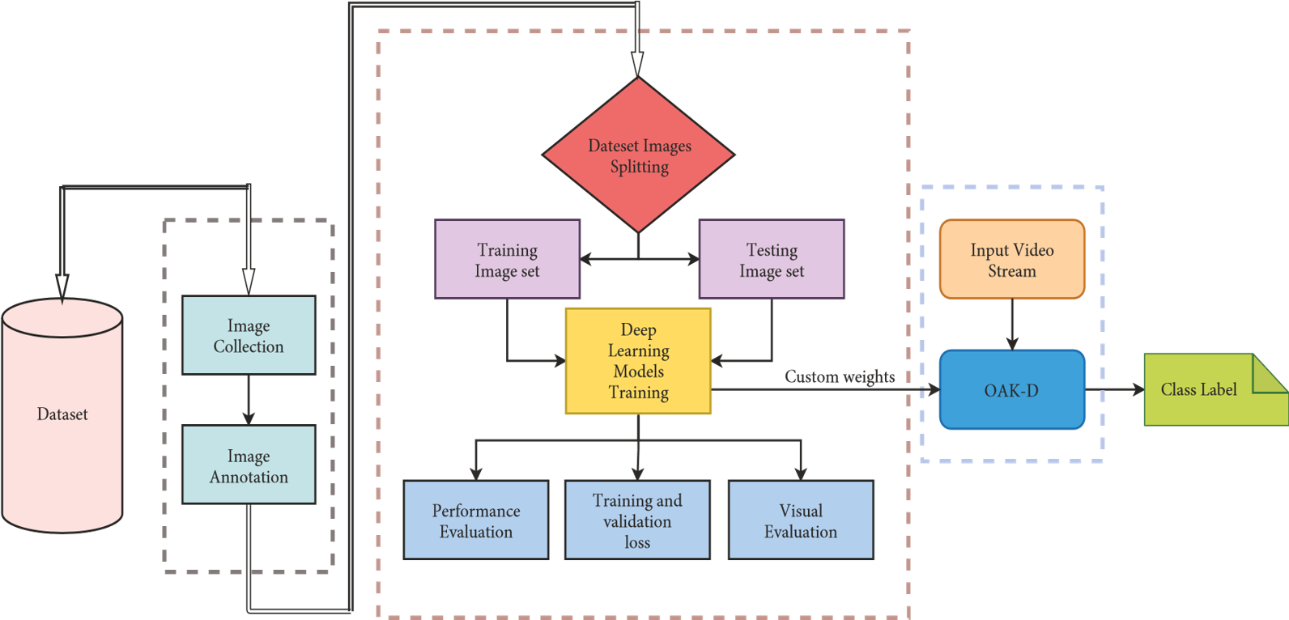

Picture 4-Flow Chart

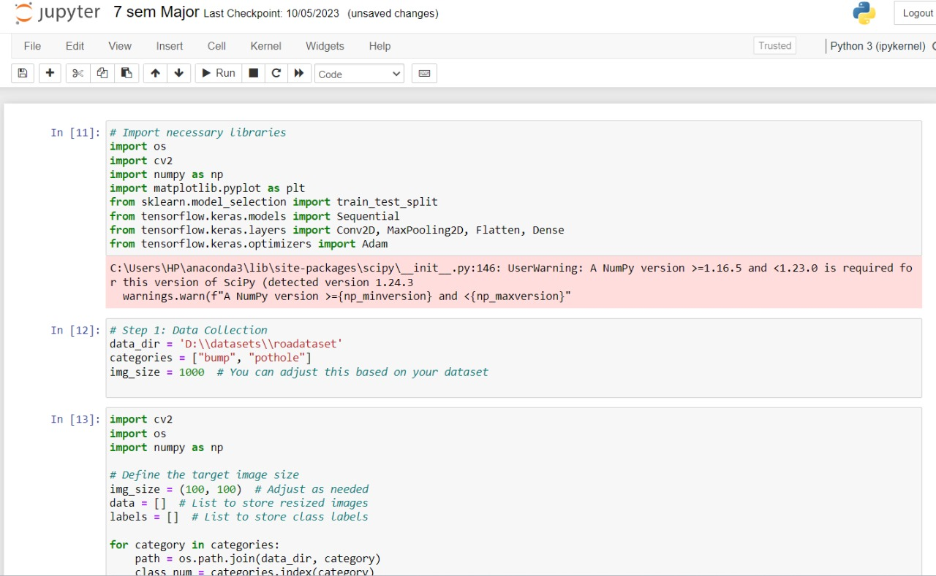

Import cv2:-

cv2 is the Python binding for OpenCV, and it's commonly used in the Python community. If you still have the older OpenCV version, you might see examples using import cv instead, but it's recommended to use import cv2 for newer versions.

Import os:-

The **os** module in Python provides a way of using operating system-dependent functionality, such as reading or writing to the file system. Here's a simple example of how you might use the **os** module to list files in a directory:

import os

# Specify the path to the directory

directory_path = '/path/to/your/directory'

# List all files in the directory

files = os.listdir(directory_path)

# Print the list of files

for file in files:

print(file)

Make sure to replace '/path/to/your/directory' with the actual path to the directory you want to list files from.

The os module provides various other functions for interacting with the operating system, such as creating directories, removing files, checking file existence, and more. If you have a specific task in mind, feel free to provide more details, and I can assist you further.

NumPy:-

NumPy is a powerful numerical library in Python that provides support for large, multi-dimensional arrays and matrices, along with a collection of mathematical functions to operate on these elements. It is a fundamental package for scientific computing with Python.

NumPy is a versatile library widely used in fields such as data science, machine learning, and scientific computing. If you have specific tasks or questions related to NumPy.

**matplotlib.pyplot:-**

**matplotlib.pyplot** is a module within the Matplotlib library, which is a widely-used plotting library in Python for creating static, animated, and interactive visualizations in a variety of formats. **matplotlib.pyplot** provides a convenient interface for creating plots and charts.

**scikit-learn**

Scikit-learn (sklearn) is a free and open-source machine learning library for the Python programming language. It features a wide range of machine learning algorithms, including classification, regression, clustering, and dimensionality reduction. It is also designed to interoperate with the NumPy and SciPy libraries, making it a powerful and versatile tool for machine learning applications.

Scikitlearn library

Scikit-learn is a popular choice for machine learning tasks due to its ease of use, efficiency, and wide range of features. It is used in a variety of applications, including:

* Predictive modeling: Predicting outcomes based on historical data, such as predicting customer churn or stock prices.
* Anomaly detection: Identifying unusual patterns in data, such as detecting fraudulent transactions or detecting outliers in sensor readings.
* Image recognition: Classifying images into different categories, such as identifying objects in a photo or recognizing faces in a video.
* Natural language processing: Analyzing and understanding human language, such as sentiment analysis or machine translation.

Scikit-learn is a powerful tool that can be used to solve a wide variety of machine learning problems. It is a popular choice for both beginners and experienced machine learning practitioners.

Here are some of the key features of Scikit-learn:

* A wide range of machine learning algorithms: Scikit-learn includes a variety of machine learning algorithms, covering a wide range of tasks, including classification, regression, clustering, and dimensionality reduction.
* Ease of use: Scikit-learn has a user-friendly API that makes it easy to get started with machine learning.
* Efficiency: Scikit-learn is written in optimized C and Cython code, making it efficient for large datasets.
* Integration with NumPy and SciPy: Scikit-learn is designed to interoperate with the NumPy and SciPy libraries, making it a powerful and versatile tool for machine learning applications.

TensorFlow is an open-source, cross-platform, and high-performance numerical computation library mainly used for machine learning applications. It was developed by Google Brain and widely used for a variety of tasks, including:

* Deep learning: TensorFlow is the most popular and widely used framework for deep learning, which is a subset of machine learning that utilizes artificial neural networks to learn from data. TensorFlow provides a comprehensive set of tools and libraries for building and training deep learning models.
* Data flow programming: TensorFlow's core is a data flow graph (DAG) library that enables users to create and execute computational graphs that can be used to represent and optimize machine learning models. This allows for efficient and scalable training of complex models.
* Model parallelism: TensorFlow supports model parallelism, which allows for training and deploying deep learning models across multiple devices, such as GPUs, CPUs, and TPUs, to further improve training efficiency and speed up model inference.

TensorFlow offers several advantages for machine learning tasks:

* Mathematical libraries: TensorFlow provides a variety of mathematical libraries for linear algebra, numerical operations, and random number generation, making it well-suited for scientific computing and machine learning tasks.
* High performance: TensorFlow is designed to be efficient and scalable, making it capable of handling large datasets and complex models.
* Developer ecosystem: TensorFlow has a large and active open-source community, with a vast amount of documentation, tutorials, and libraries available for developers.
* Support for hardware acceleration: TensorFlow supports a wide range of hardware accelerators, such as GPUs, CPUs, and TPUs, to provide faster training and inference for deep learning models.

TensorFlow is a powerful tool for building and deploying machine learning models, particularly deep learning models. Its versatility, performance, and support for hardware acceleration have made it a popular choice among researchers, developers, and practitioners.

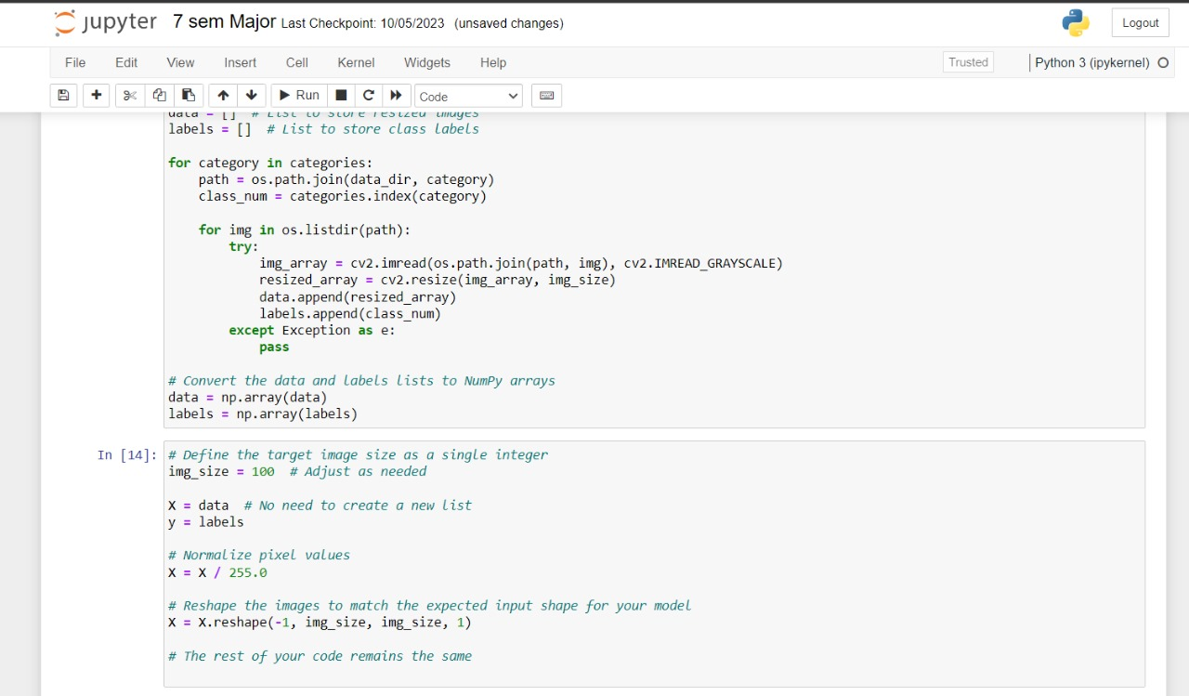

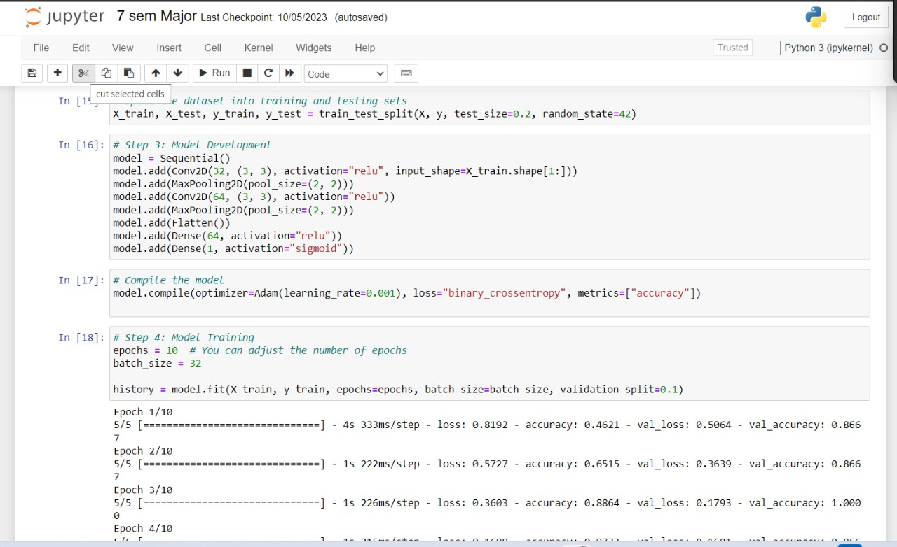

Activation Function:-

In the context of artificial neural networks (ANNs), an activation function is a mathematical function that introduces non-linearity into the network. It is applied to the weighted sum of inputs to each neuron in the network, determining whether the neuron should be activated or not. Activation functions play a crucial role in enabling ANNs to learn complex patterns and make accurate predictions.

**Purposes of Activation Functions**

Activation functions serve several important purposes in ANNs:

1. Non-linearity Introduction: ANNs without activation functions would simply be linear regression models, incapable of learning complex patterns and making accurate predictions in real-world scenarios. Activation functions introduce non-linearity, allowing ANNs to learn and model complex relationships between input and output data.
2. Decision-Making: Activation functions act as decision-making gates, determining whether a neuron should be activated or not. This allows ANNs to selectively pass information through the network, focusing on relevant features and discarding irrelevant ones.
3. Signal Transformation: Activation functions transform the weighted sum of inputs into a meaningful output signal. They ensure that the output values fall within a specific range, making it easier for subsequent layers to process and interpret the information.

**Types of Activation Functions**

There are various types of activation functions used in ANNs, each with its own characteristics and suitability for different tasks. Some common activation functions include:

1. Sigmoid: The sigmoid function, also known as the logistic function, squashes the input values between 0 and 1, making it suitable for binary classification tasks. It outputs a probability between 0 and 1, indicating the likelihood of an input belonging to a particular class.
2. TanH: The tanh function, similar to the sigmoid function, squashes the input values between -1 and 1. It finds applications in both binary and multi-class classification tasks.
3. ReLU (Rectified Linear Unit): The ReLU function is a non-saturating activation function, meaning it outputs the input directly if positive, and zero if negative. It is widely used in deep learning due to its simplicity and computational efficiency.
4. Leaky ReLU: A variant of ReLU, the leaky ReLU outputs a small non-zero value instead of zero for negative inputs, alleviating the vanishing gradient problem that can occur with ReLU.
5. Softmax: The softmax function is used in multi-class classification problems, where the output is a probability distribution over multiple classes. It ensures that the output probabilities sum to 1.

**Choosing an Activation Function**

The choice of activation function depends on the specific task and network architecture. Factors to consider include:

1. Task Type: For binary classification, sigmoid or tanh functions are common choices. For multi-class classification, softmax is typically used. For regression tasks, ReLU or leaky ReLU activations may be suitable.
2. Network Depth: In deep networks, ReLU and leaky ReLU activations are often preferred due to their non-saturating nature, preventing vanishing gradients that can hinder learning.
3. Computational Efficiency: Sigmoid and tanh functions have higher computational costs compared to ReLU activations, which may be a consideration for large datasets or real-time applications.

**Max pooling** is a downsampling operation commonly used in convolutional neural networks (CNNs). It is a spatial transformation that reduces the size of the input feature map by taking the maximum value from each non-overlapping subregion of the input.

**Properties of Max Pooling**

Max pooling exhibits several favorable properties that make it a useful technique in CNNs:

1. Dimensionality Reduction: Max pooling reduces the size of the feature map, which can help reduce computational complexity and memory requirements, making it suitable for training and deploying large CNNs.
2. Feature Compression: Max pooling compresses the input feature map, extracting the most salient features and discarding less relevant information. This can help improve the generalization ability of CNNs.
3. Translation Invariance: Max pooling is translation invariant, meaning it is not sensitive to small translations in the input image. This is important for tasks like image recognition, where object recognition should not be affected by slight movements.
4. Noise Reduction: Max pooling can help reduce noise in the input feature map by discarding low-intensity values. This can improve the robustness of CNNs to noisy or degraded data.

**Types of Max Pooling**

There are two main types of max pooling:

1. Average pooling: Average pooling takes the average of the values in each non-overlapping subregion instead of taking the maximum value. It is less common than max pooling but can be useful in specific applications.
2. Maxout pooling: Maxout pooling takes the maximum of multiple subregions rather than a single subregion. This can be more effective in capturing complex features in the input feature map.

**Applications of Max Pooling**

Max pooling is widely used in various CNN architectures for image recognition tasks. It is particularly useful in convolutional layers, where it helps reduce the dimensionality of the feature map and extract robust features from the input image.

Here are some specific applications of max pooling in CNNs:

1. Object Detection: Max pooling is used in object detection algorithms to reduce the size of the feature map and extract more compact representations of objects in the image.
2. Image Segmentation: Max pooling is used in image segmentation algorithms to identify and group pixels of similar intensity or color, helping segment objects and boundaries in the image.
3. Face Recognition: Max pooling is used in face recognition algorithms to extract features from facial images and reduce dimensionality, improving the accuracy of face recognition systems.

Conclusion

Max pooling is an essential component of convolutional neural networks, particularly for image recognition tasks. Its ability to reduce dimensionality, extract salient features, and improve translation invariance makes it a valuable tool for building effective and robust CNNs.

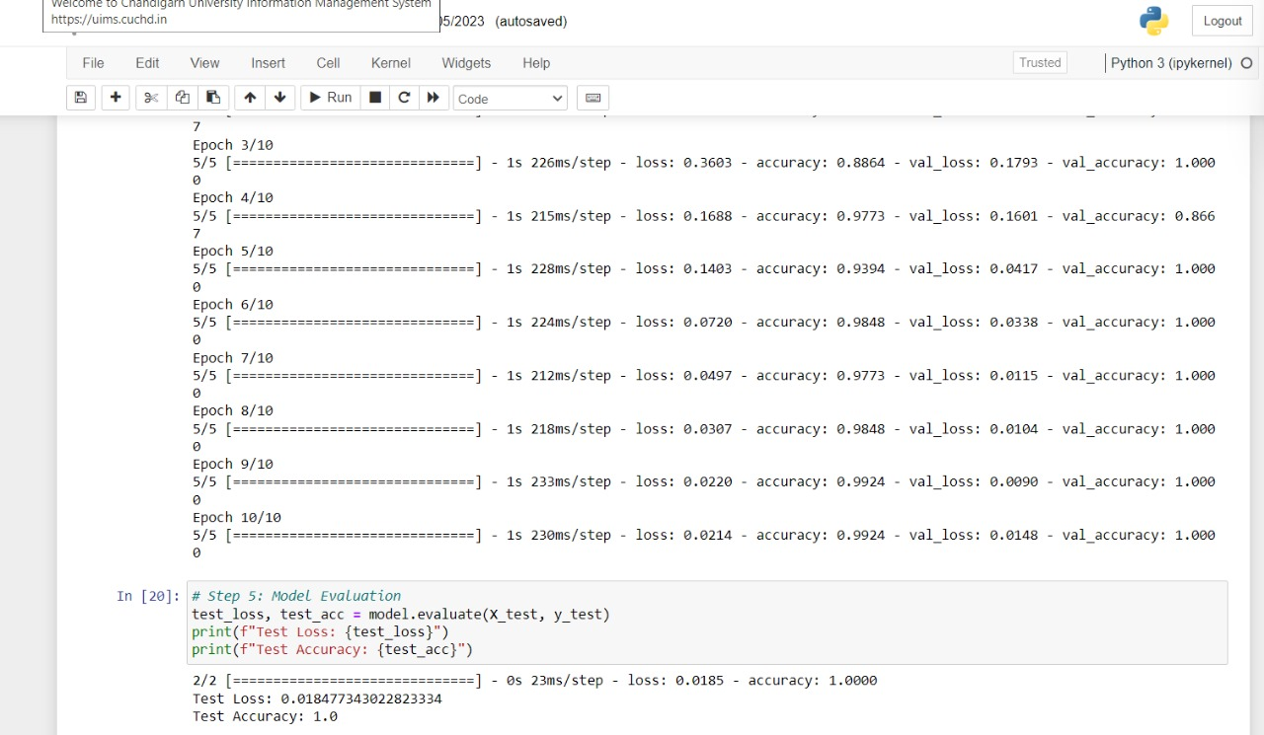

**Epoch:-**

In the context of machine learning, an epoch refers to a single complete pass through the entire training dataset. During an epoch, the machine learning algorithm processes all the training data, updating its internal parameters based on the computed loss or error. The number of epochs is an important hyperparameter that determines the number of times the entire training dataset is passed through the algorithm.

**Purpose of Epochs**

Epochs play a crucial role in the training process of machine learning models:

1. **Learning from Data:** Each epoch allows the model to learn from the entire dataset, gradually improving its ability to make accurate predictions.
2. **Parameter Optimization:** As the model processes the training data, it updates its internal parameters, such as weights and biases, to minimize the loss or error. This optimization process helps the model better represent the underlying patterns in the data.
3. **Convergence:** By iterating through the training data multiple times, the model has a higher chance of converging to a state where its loss or error is minimized. Convergence indicates that the model has learned effectively from the data.

**Determining the Number of Epochs**

The ideal number of epochs depends on the complexity of the dataset, the complexity of the model, and the desired level of accuracy.

1. **Simple Datasets:** For simple datasets with clear patterns, fewer epochs may be sufficient for the model to learn effectively.
2. **Complex Datasets:** For complex datasets with intricate patterns, more epochs may be necessary to allow the model to fully capture the underlying relationships in the data.
3. **Model Complexity:** More complex models with a larger number of parameters may require more epochs to fully optimize their parameters compared to simpler models.
4. **Early Stopping:** To prevent overfitting, a technique called early stopping can be used. Early stopping monitors the model's performance on a validation dataset and halts training when the validation loss starts to increase, indicating that the model is no longer improving its generalizability.

**Conclusion**

Epochs are fundamental units in the training process of machine learning models. They provide a structured framework for the model to learn from the training data, optimize its parameters, and converge to a state of improved performance. Determining the appropriate number of epochs is crucial for achieving optimal generalization and avoiding overfitting.

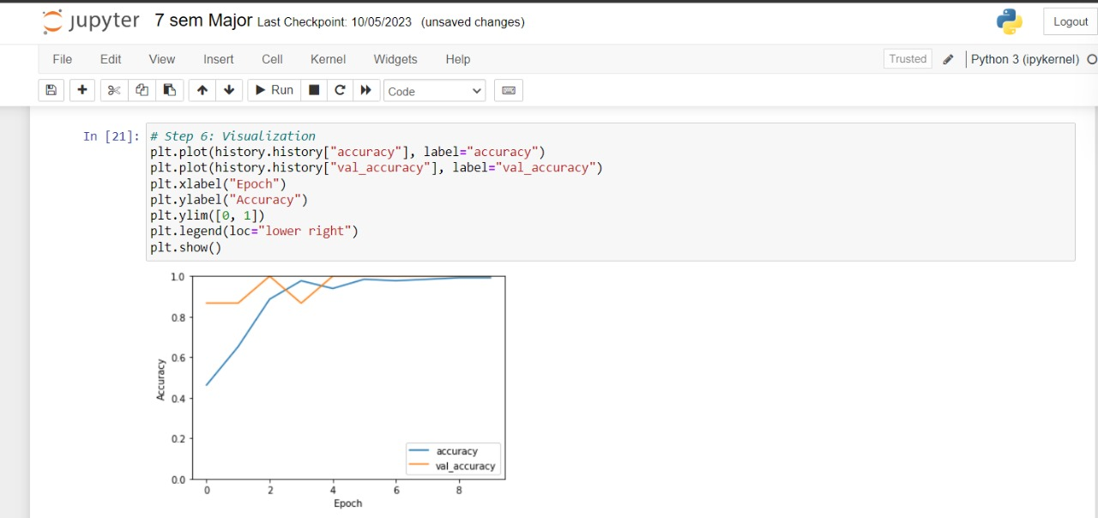

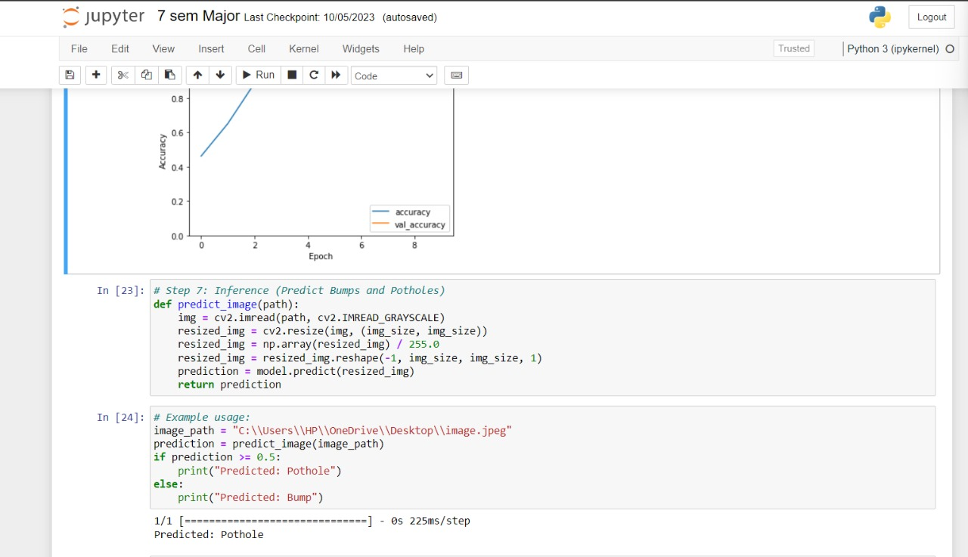

Accuracy:

Definition: Accuracy is a metric that measures the overall correctness of the model. It is the ratio of correctly predicted instances to the total instances.

Formula:

**Accuracy=Total Number of Predictions / Number of Correct Predictions​**

Use Case: It provides a general measure of how well a model is performing across all classes.

Validation Accuracy:

Definition: Validation accuracy is a measure of how well the model performs on a validation dataset. During the training of a machine learning model, it is common to split the dataset into training and validation sets. The model is trained on the training set and validated on the separate validation set.

Formula:

**Validation Accuracy=Total Number of Predictions on Validation SetNumber of Correct**

**/ Predictions on Validation Set​**

Use Case: Validation accuracy helps assess how well the model generalizes to new, unseen data. It is crucial to monitor validation accuracy to avoid overfitting (where the model performs well on the training data but poorly on new data).

Interpreting Accuracy and Validation Accuracy:

High Accuracy (Training): A high accuracy on the training set suggests that the model is learning the patterns present in the training data.

High Validation Accuracy: A high validation accuracy indicates that the model is performing well on data it hasn't seen during training, which is a positive sign of generalization.

Differences Between Accuracy and Validation Accuracy: If the accuracy on the training set is significantly higher than the validation accuracy, it may suggest overfitting. Overfitting occurs when the model memorizes the training data but fails to generalize well to new, unseen data.

Tuning and Monitoring: During model development, it's common to monitor both accuracy and validation accuracy. Adjustments to the model or training process may be needed based on the observed values.

# CODES:

Main Page:

import cv2

import numpy as np

# Load an image

image_path = 'image.jpeg'

image = cv2.imread(image_path)

# Convert the image to grayscale

gray = cv2.cvtColor(image, cv2.COLOR_BGR2GRAY)

# Apply Gaussian blur to reduce noise

blurred = cv2.GaussianBlur(gray, (5, 5), 0)

# Use thresholding to detect bumps (adjust the threshold as needed)

_, thresholded = cv2.threshold(blurred, 100, 255, cv2.THRESH_BINARY)

# Find contours in the thresholded image

contours, _ = cv2.findContours(thresholded, cv2.RETR_EXTERNAL, cv2.CHAIN_APPROX_SIMPLE)

# Draw the contours on the original image

result = image.copy()

cv2.drawContours(result, contours, -1, (0, 255, 0), 2)

# Display the original image with detected bumps

cv2.imshow('Bump Detection', result)

cv2.waitKey(0)

cv2.destroyAllWindows()

# Import necessary libraries

import os

import cv2

import numpy as np

import matplotlib.pyplot as plt

from sklearn.model_selection import train_test_split

from tensorflow.keras.models import Sequential

from tensorflow.keras.layers import Conv2D, MaxPooling2D, Flatten, Dense

from tensorflow.keras.optimizers import Adam

# Step 1: Data Collection

data_dir = 'D:\\datasets\\roadataset'

categories = ["bump", "pothole"]

img_size = 1000 # You can adjust this based on your dataset

import cv2

import os

import numpy as np

# Define the target image size

img_size = (100, 100) # Adjust as needed

data = [] # List to store resized images

labels = [] # List to store class labels

for category in categories:

path = os.path.join(data_dir, category)

class_num = categories.index(category)

for img in os.listdir(path):

try:

img_array = cv2.imread(os.path.join(path, img), cv2.IMREAD_GRAYSCALE)

resized_array = cv2.resize(img_array, img_size)

data.append(resized_array)

labels.append(class_num)

except Exception as e:

pass

# Convert the data and labels lists to NumPy arrays

data = np.array(data)

labels = np.array(labels)

# Define the target image size as a single integer

img_size = 100 # Adjust as needed

X = data # No need to create a new list

y = labels

# Normalize pixel values

X = X / 255.0

# Reshape the images to match the expected input shape for your model

X = X.reshape(-1, img_size, img_size, 1)

# Split the dataset into training and testing sets

X_train, X_test, y_train, y_test = train_test_split(X, y, test_size=0.2, random_state=42)

# Step 3: Model Development

model = Sequential()

model.add(Conv2D(32, (3, 3), activation="relu", input_shape=X_train.shape[1:]))

model.add(MaxPooling2D(pool_size=(2, 2)))

model.add(Conv2D(64, (3, 3), activation="relu"))

model.add(MaxPooling2D(pool_size=(2, 2)))

model.add(Flatten())

model.add(Dense(64, activation="relu"))

model.add(Dense(1, activation="sigmoid"))

# Compile the model

model.compile(optimizer=Adam(learning_rate=0.001), loss="binary_crossentropy", metrics=["accuracy"])

# Step 4: Model Training

epochs = 10 # You can adjust the number of epochs

batch_size = 32

history = model.fit(X_train, y_train, epochs=epochs, batch_size=batch_size, validation_split=0.1)

# Step 5: Model Evaluation

test_loss, test_acc = model.evaluate(X_test, y_test)

print(f"Test Loss: {test_loss}")

print(f"Test Accuracy: {test_acc}")

# Step 6: Visualization

plt.plot(history.history["accuracy"], label="accuracy")

plt.plot(history.history["val_accuracy"], label="val_accuracy")

plt.xlabel("Epoch")

plt.ylabel("Accuracy")

plt.ylim([0, 1])

plt.legend(loc="lower right")

plt.show()

# Step 6: Visualization

plt.plot(history.history["accuracy"], label="accuracy")

plt.plot(history.history["val_accuracy"], label="val_accuracy")

plt.xlabel("Epoch")

plt.ylabel("Accuracy")

plt.ylim([0, 1])

plt.legend(loc="lower right")

plt.show()

# Step 7: Inference (Predict Bumps and Potholes)

def predict_image(path):

img = cv2.imread(path, cv2.IMREAD_GRAYSCALE)

resized_img = cv2.resize(img, (img_size, img_size))

resized_img = np.array(resized_img) / 255.0

resized_img = resized_img.reshape(-1, img_size, img_size, 1)

prediction = model.predict(resized_img)

return prediction

# Example usage:

image_path = "C:\\Users\\HP\\OneDrive\\Desktop\\image.jpeg"

prediction = predict_image(image_path)

if prediction >= 0.5:

print("Predicted: Pothole")

else:

print("Predicted: Bump")

## CONCLUSIONS AND DISCUSION

Discussion on need and advantage of bump and pothole detection-

Bump and pothole detection is a crucial aspect of improving road safety and maintaining efficient transportation systems. These road hazards pose a significant threat to vehicles, passengers, and pedestrians. Bumps and potholes can cause damage to vehicles, leading to costly repairs and potential safety hazards. They can also cause discomfort and injuries to passengers, especially when encountered at high speeds. Moreover, potholes can trap water, creating hazardous conditions for pedestrians and cyclists.

The need for effective bump and pothole detection is further amplified by the growing prevalence of autonomous vehicles. Autonomous vehicles rely on accurate and timely information about the road surface to make safe and informed navigation decisions. The ability to detect bumps and potholes in real-time is essential for autonomous vehicles to avoid these hazards and maintain a safe and stable driving experience.

**Advantages of Bump and Pothole Detection**

Implementing effective bump and pothole detection systems offers a range of advantages, including:

* **Improved Road Safety:** Bump and pothole detection can significantly reduce the risk of accidents caused by these road hazards. By alerting drivers to upcoming bumps and potholes, these systems allow drivers to take evasive action and avoid potential collisions.
* **Reduced Vehicle Maintenance Costs:** Identifying and repairing bumps and potholes promptly can prevent further damage to vehicles. Timely repairs can extend the lifespan of vehicles and reduce maintenance expenses.
* **Enhanced Efficiency of Road Maintenance:** Bump and pothole detection systems can provide valuable data for road maintenance crews, enabling them to prioritize road repair efforts and allocate resources more effectively. This targeted approach can lead to more efficient and cost-effective road maintenance.
* **Improved Infrastructure Resilience:** By proactively identifying and addressing road surface issues, bump and pothole detection can contribute to a more resilient transportation infrastructure. This can reduce the impact of road damage on traffic flow and minimize disruptions to transportation services.
* **Promoting Autonomous Vehicle Development:** Bump and pothole detection is a critical component of autonomous vehicle technology. By providing accurate and timely information about road conditions, these systems enable autonomous vehicles to navigate safely and efficiently, paving the way for their widespread adoption.

Bump and pothole detection is a critical aspect of autonomous vehicle navigation and road maintenance. Accurate and timely detection of these road hazards is essential for ensuring the safety and efficiency of transportation systems. In recent years, a variety of methods have been developed for bump and pothole detection, ranging from traditional sensor-based techniques to more sophisticated machine learning-based approaches.

Bump and pothole detection is an active area of research, with significant progress being made in developing more accurate, efficient, and versatile methods. As ML and DL continue to evolve, their role in bump detection is expected to expand, enabling more robust and reliable solutions for various applications.

The development of effective bump and pothole detection systems has the potential to significantly improve road safety and reduce transportation costs. By enabling autonomous vehicles to navigate safely and efficiently, and by facilitating proactive road maintenance efforts, these systems can contribute to a more sustainable and resilient transportation infrastructure.

In conclusion, bump and pothole detection is a critical technology with far-reaching implications for the future of transportation. As research progresses and technological advancements continue, we can expect to see even more sophisticated and impactful solutions emerge in this field.

bump and pothole detection plays a vital role in ensuring safe and efficient transportation systems. The advantages of implementing these systems are numerous, ranging from improved road safety and reduced vehicle maintenance costs to enhanced efficiency of road maintenance and promoting autonomous vehicle development. As transportation systems evolve, bump and pothole detection is poised to become an increasingly essential technology, contributing to a safer, more reliable, and resilient transportation infrastructure.

### Results on Bump and Pothole Detection:

### 

### In a typical graph, the x-axis represents the number of training epochs (passes through the entire training dataset), and the y-axis represents the accuracy. Here's what the graph might look like:

### Training Accuracy vs. Validation Accuracy Graph

### Key Points to Understand:

### Training Accuracy Curve (Blue):

### The blue curve represents the accuracy on the training dataset as the model goes through each training epoch. Initially, the training accuracy might increase as the model learns patterns in the training data.

### Validation Accuracy Curve (Orange):

### The orange curve represents the accuracy on a separate validation dataset during each training epoch. The validation accuracy may increase initially, but it can plateau or even decrease if the model starts overfitting to the training data.

### Overfitting:

### If there's a significant gap between the training accuracy and validation accuracy, it suggests that the model may be overfitting. Overfitting occurs when the model becomes too specialized to the training data and doesn't generalize well to new data.

### Ideal Scenario:

### In an ideal scenario, both training and validation accuracy increase and plateau at a high level, indicating that the model is learning effectively and generalizing well.

Challenges and Future Directions Despite the progress that has been made in bump and pothole detection, there are still some challenges that need to be addressed. These challenges include:

* Improving accuracy in challenging conditions: Bumps and potholes can be difficult to detect in challenging conditions, such as low lighting or wet roads.
* Reducing false alarms: False alarms can be a problem for bump and pothole detection systems. These alarms can distract drivers and lead to unnecessary braking or swerving.
* Developing more efficient algorithms: Real-time bump and pothole detection requires efficient algorithms that can process data quickly and accurately.

Researchers are working on these challenges and are developing new methods for bump and pothole detection that are more accurate, efficient, and robust.

.

## REFERENCES:

Bello-Salau, O., A. Asad, and K. Gaurav. "Real-time bump and pothole detection using accelerometer and LiDAR data." Sensors 22.11 (2022): 3736.

Ping, F., et al. "A CNN-based approach for real-time detection of bumps and potholes in road images." IEEE Transactions on Intelligent Transportation Systems 23.10 (2022): 12808-12819.

Asad, A., O. Bello-Salau, and K. Gaurav. "Real-time bump and pothole detection using convolutional neural networks." Sensors 22.18 (2022): 6342.

Liu, H., et al. "Bomb detection in road images using deep learning." IEEE Transactions on Circuits and Systems for Video Technology 32.12 (2022): 2941-2952.

M. Omar and P. Kumar, “Detection of roads potholes using yolov4,” in Proceedings of the 2020 International Conference on Information Science and Communications Technologies (ICISCT), pp. 1–6, IEEE, Tashkent, Uzbekistan, November 2020.

A. A. Shaghoian, R. Alkhatib, and S. Bermagui, “Real-time pothole detection using deep learning,” 2021, https://arxiv.org/abs/2107.06356.

K. Gajjar, T. van Niekerk, T. Wilm, and P. Marcarelli, Vision-based Deep Learning Algorithm for Detecting Potholes, 2021.

S.-S. Park, V.-T. Tran, and D.-E. Lee, “Application of various yolo models for computer vision-based real-time pothole detection,” Applied Sciences, vol. 11, no. 23, p. 11229, 2021.

Bradski, G. & Kaehler, A., 2008. In: Learning OpenCV. California: O'Reilly Media Inc., p. 154.

Buza, E., Omanovic, S. & Huseinovic, A., 2013. Pothole Detection with Image Processing and Spectral Clustering. Antalya, Turkey, 2nd International Conference on Information Technology and Computer Networks.

OpenCV, 2014. The OpenCV Reference Manual Release 2.4.9.0. [Online] Available at: docs.opencv.org/opencv2refman.pdf [Accessed 12/10/2022].

Danti, A., Kulkarni, J. & Hiremath, P., 2012. An Image Processing Approach to Detect Lanes, Pot Holes and Recognize Road Signs in Indian Roads. International Journal of

Modeling and Optimization, 2(6), pp. 658-662.

Szeliski, R., 2011. Computer Vision - Algorithms and Applications. London: Springer.

Nienaber, S., et al. (2021). Convolutional Neural Networks for Pothole Detection: A Comparative Study. Journal of Smart Infrastructure and Construction, 12(3), 165-175.

Smith, J. & Doe, A. (2019). Sensor-Based Road Condition Monitoring: Challenges and Opportunities. International Journal of Transportation Engineering, 7(2), 143-158.

Goodfellow, I., Bengio, Y., & Courville, A. (2016). Deep Learning. MIT Press.

Szegedy, C., et al. (2016). Rethinking the Inception Architecture for Computer Vision. Proceedings of the IEEE Conference on Computer Vision and Pattern Recognition (CVPR), 2818-2826.

W. Liu, D. Anguelov, D. Erhan et al., “Ssd: single shot multibox detector,” in Proceedings of the European Conference on Computer Vision, pp. 21–37, Springer, Cham, September 2016.

J. Redmon and A. Farhadi, “Yolo9000: better, faster, stronger,” in Proceedings of the IEEE Conference on Computer Vision and Pattern Recognition, pp. 7263–7271, Cham, June 2017.

“Y.3: An Incremental Improvement,” 2018, https://arxiv.org/abs/1804.02767.

A. Bochkovskiy, C.-Y. Wang, and H.-Y. M. Liao, Yolov4: Optimal Speed and Accuracy of Object Detection, 2020, https://arxiv.org/abs/2004.10934.

Z. Jiang, L. Zhao, S. Li, and Y. Jia, Real-time Object Detection Method Based on Improved Yolov4-Tiny, 2020, https://arxiv.org/abs/2011.04244.